Name___________________ Date_______ Hour______

Chapter 4 Section 1
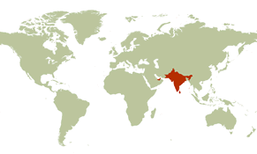
The Indus and Ganges River Valleys

I. India’s geographic setting
A. Monsoon climate
1.Winter monsoons bring dry air
2. People depend on summer monsoons for
rain for crops

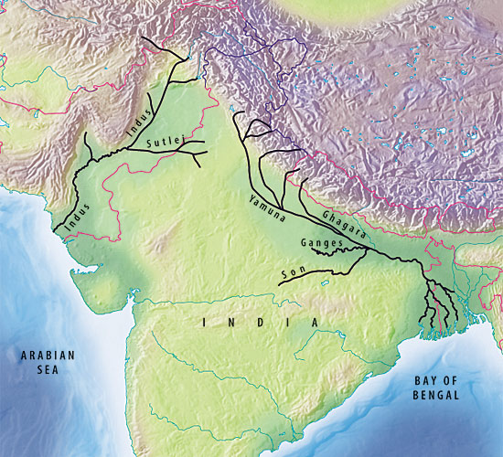
B. Barriers and pathways
1. Himalayas form barrier between India and
other lands
2. Indus and Ganges rivers flow from the Himalayas

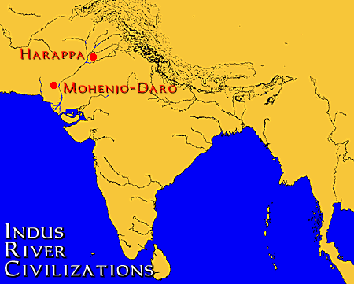
II. Life in the Indus River Valley
A. Ancient city planners
1. Mohenjo-Daro built above ground level
2. Buildings were laid out in blocks
3. Citadel was at city’s highest point
4. Clay pipes under the streets carried
waste from homes and public buildings

B. Life in Mohenjo-Daro
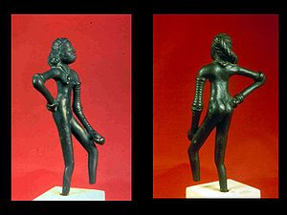
1. City active with merchants, artisans, and traders
2. People enjoyed toys, pets, games, and music
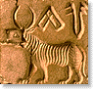
3. Language, writing, government, and religion are unknown to historians

C. Mysterious decline
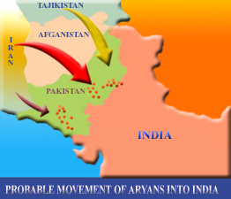
1. Around 2000 B.C., Indus Valley farmers began to abandon their land
2. Between 2000 and 1500 B.C., newcomers from the north entered the valley

III. A new culture arises
A. Aryan culture spreads
1. Combined traditions of original inhabitants with ideas and beliefs brought by Aryans
2. Spread from Indus Valley to Ganges Valley

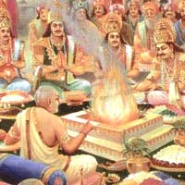
B. Aryan life
1. Religious leaders were priests, called Brahmans
2. Society was organized into four classes

C. Social order
1. By 500 B.C., there was a strict division of classes
2. People had to stay in the caste, or class, of
their parents

