Name___________________ Date_______ Hour______

Chapter 4 Section 1
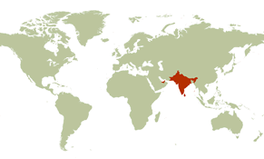
The Indus and Ganges River Valleys

I. India’s geographic setting
A. Monsoon climate
1.Winter monsoons ___________________
2. People depend on summer monsoons for
____________________

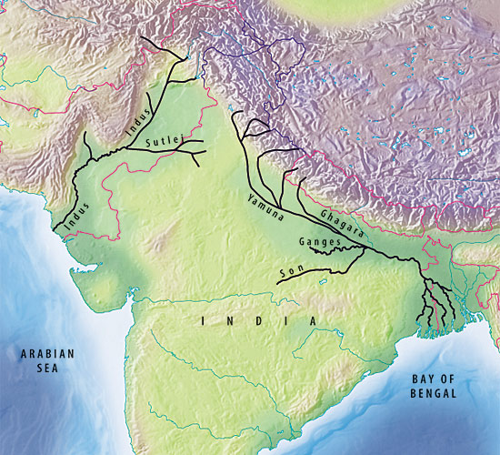
B. _______________________________
1. Himalayas form barrier _________________
____________
2. Indus and Ganges rivers flow from the ________________________

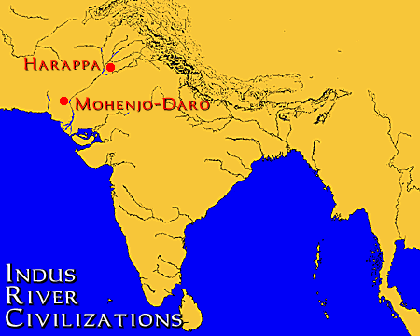
II. ____________________________________
A. Ancient city planners
1. ____________ built above ground level
2. Buildings were laid out in blocks
3. ________________ city’s highest point
4. ____________ under the streets carried
waste from homes and public buildings

B. Life in Mohenjo-Daro
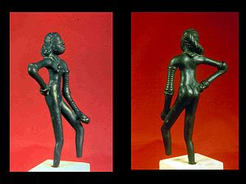
1. City active with _______________________ ______________
2. People enjoyed _______________________ _____________________________________
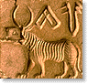
3. Language, writing, government, and religion are ________________ to historians

C. _______________decline
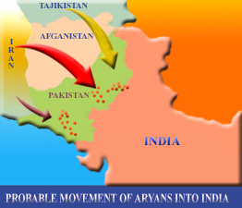
1. Around 2000 B.C., Indus Valley farmers began to ____________________________
2. Between 2000 and 1500 B.C., newcomers from the north entered the valley

III. __________________________________
A. ________________ culture spreads
1. Combined traditions of original inhabitants with ideas and beliefs brought by Aryans
2. Spread from Indus Valley to _____________

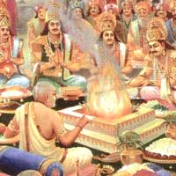
B. Aryan life
1. Religious leaders were priests, called __________________________
2. Society was organized into _____________

C. Social order
1. By 500 B.C., there was a ________________ _________________________
2. People had to stay in the caste, or class, of
_________________

